R.Aishwarya

192125001

ETHICAL HACKING FOR MOBILE APPS-ITA1437

1.Information gathering using the harvester.

Screenshorts:

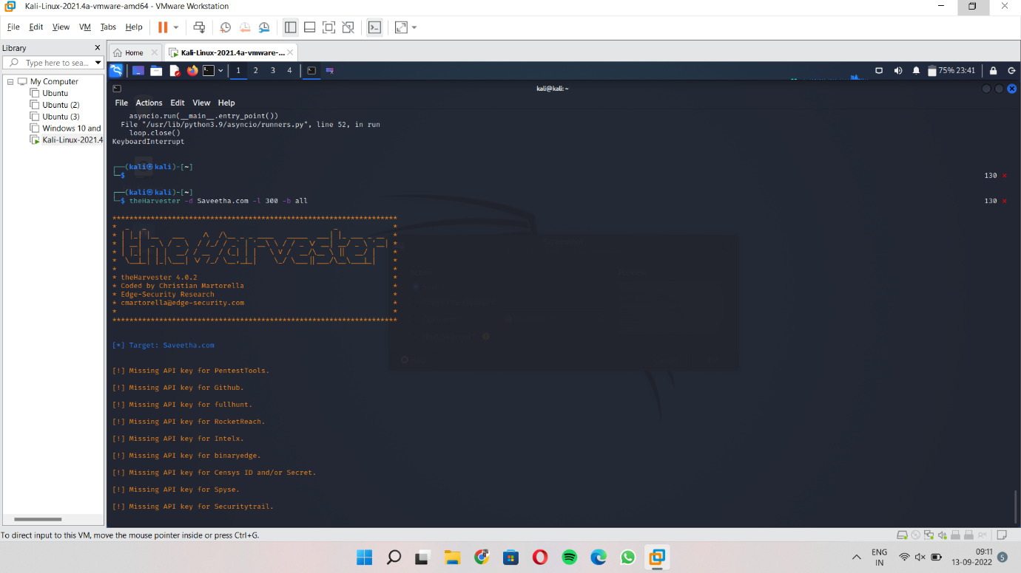

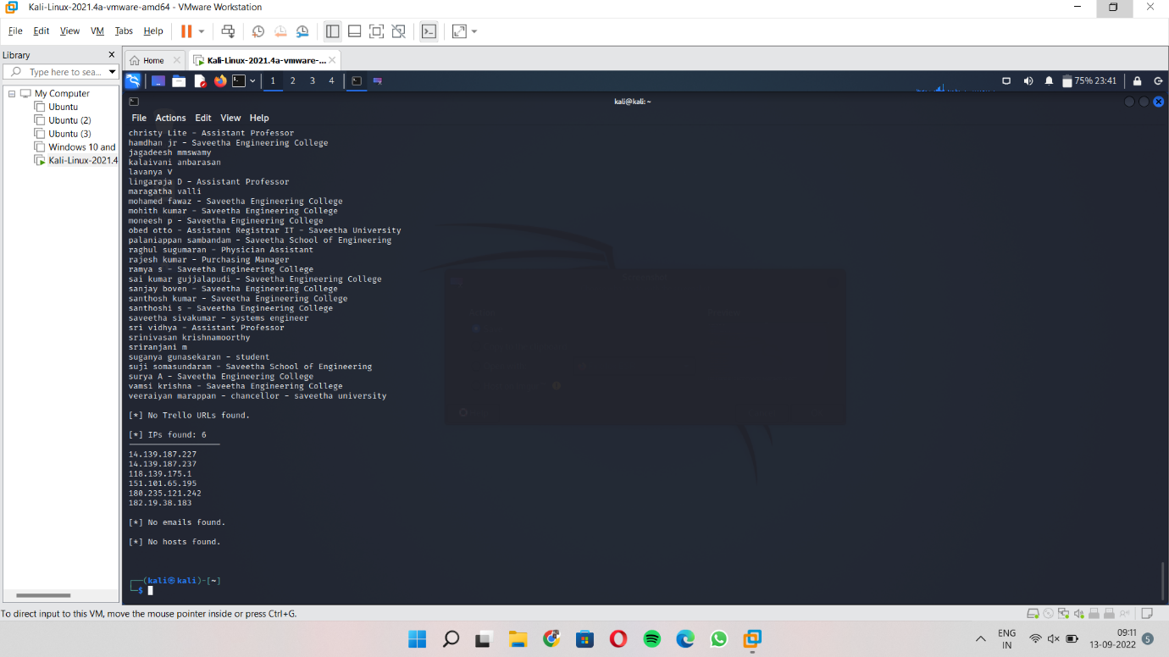

2.Opensource intelligence gathering using OSRFramework.

Screenshorts:

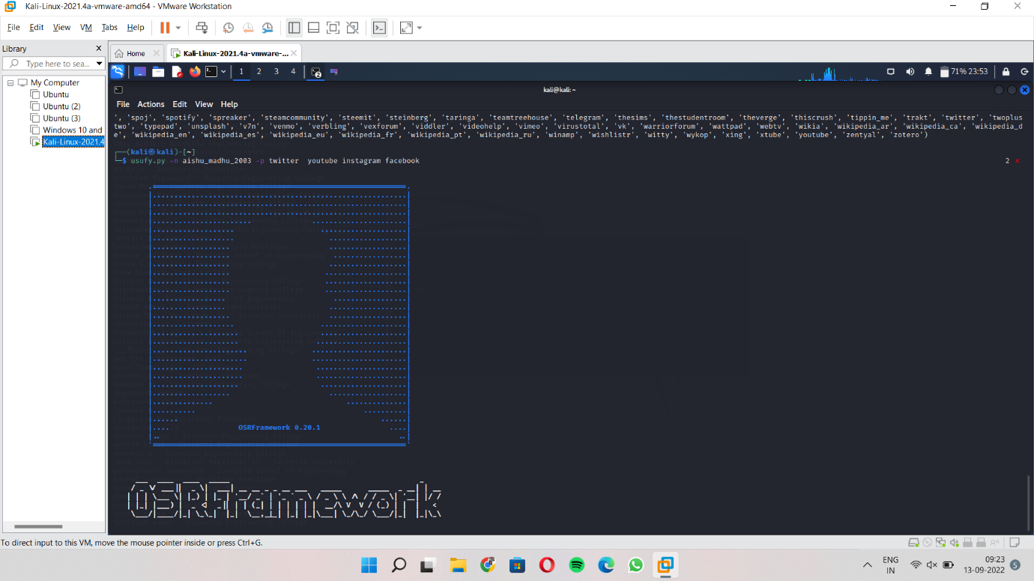

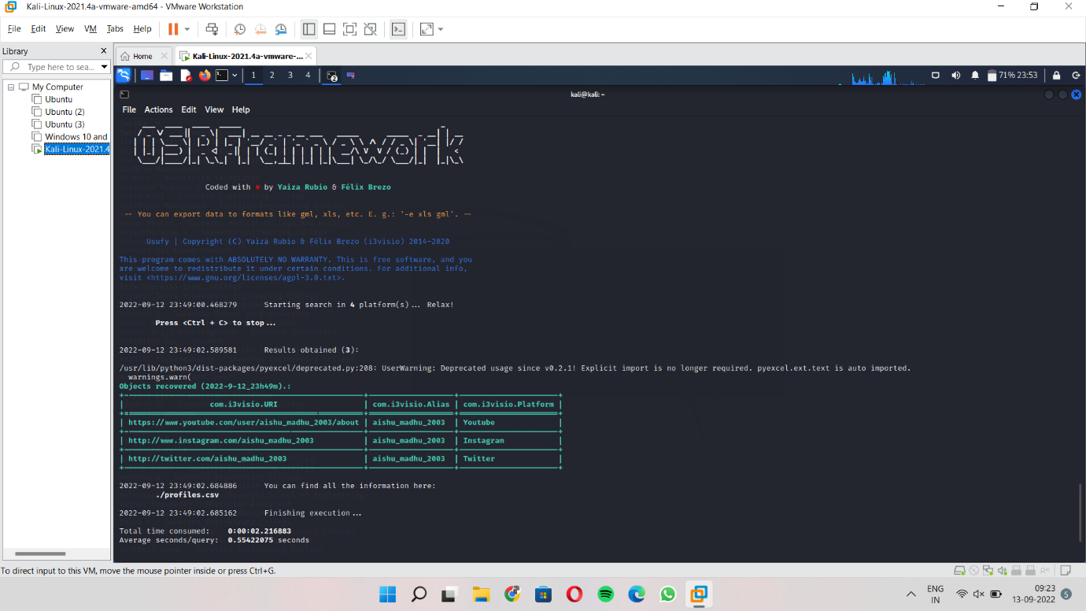

3.Use google and whois for reconnaissance.

Screenshorts:

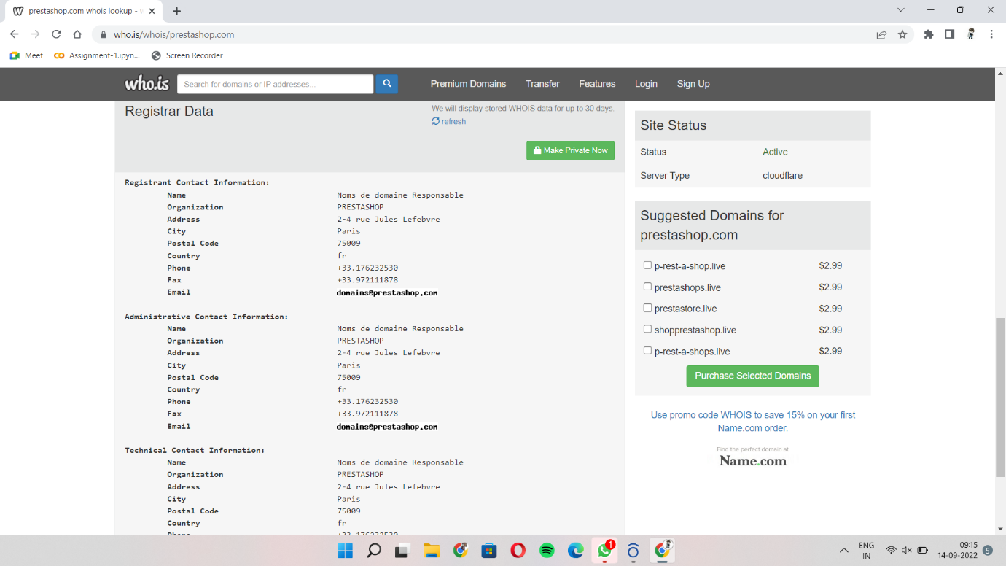

4.Using TraceRoute,ping,ifconfig,netstat commamd.

Screenshort:

